|  |
| --- |
| Circle Language Spec: Commands |

## Parameters in an Inactive Clause in a Diagram

This article demonstrates a situation of command objects.

This article illustrates how parameters in an inactive clause look in a diagram.

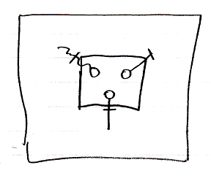

The large square is a command definition the inactive clause is in. The square inside the square is the inactive clause. The inactive clause contains three circles, which are the parameters in the clause. The lines connected to the circles, which are also dissected by an access mark, are the parameter passings. Parameter passings are explained in the *parameter* articles.